1. List only directories and one level from Linux root directory.

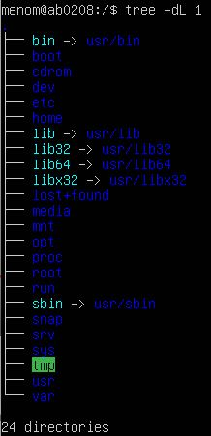

1. List /var/log directory content with two levels and full path prefix for each file.



1. List /bin directory content with owner information, size in human readable format and name starting with 'xs'. tree -uhP “xs\*” /bin

